**Practical : 4**

**AIM:** Practical of Hypothesis testing.

**A.**Hypothesis testing of a Single Population means.

Hypothesis testing is a form of statistical inference that uses data from a sample to draw conclusions about apopulation parameter or a population probability distribution.First, a tentative assumption is made about the parameter or distribution. This assumption is called the null hypothesis and is denoted by H0. An alternative hypothesis (denoted Ha), which is the opposite of what is stated in the null hypothesis, is then defined. The hypothesis-testing procedure involves using sample data todetermine whether or not H0 can be rejected. If H0 is rejected, the statistical conclusion is that the alternativehypothesis Ha is true.

**Step 1:** First we have to create Excel file and Enter the 28 values so that we can fine deviation, Square of deviation, population, differentiate of mean, T-value, and system .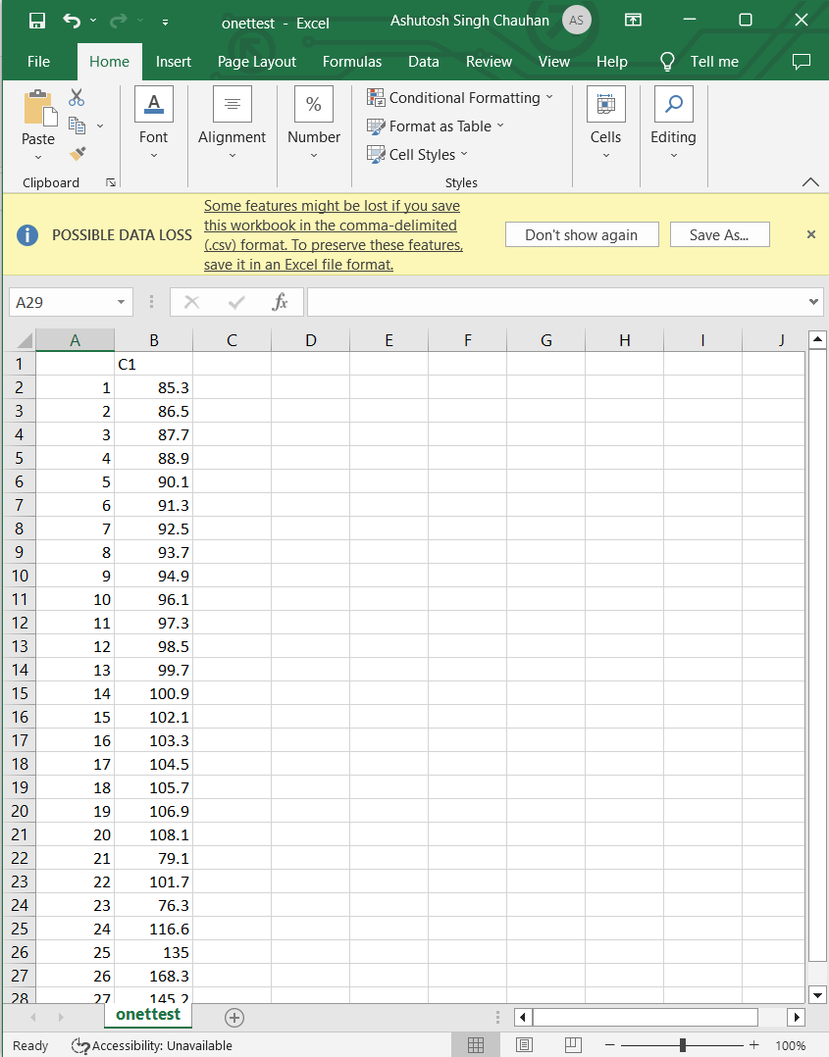

Step 2:Now we have to import Excel file (onetest.csv) type bellow command.

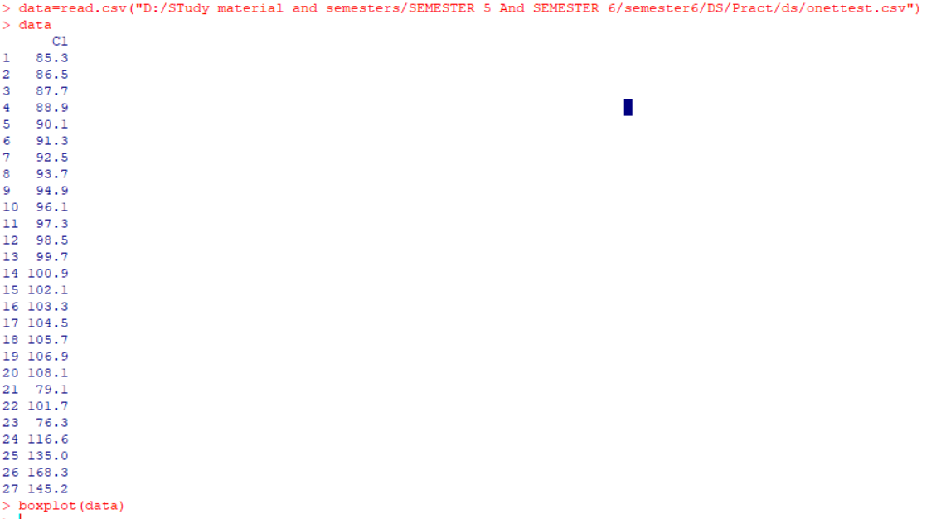

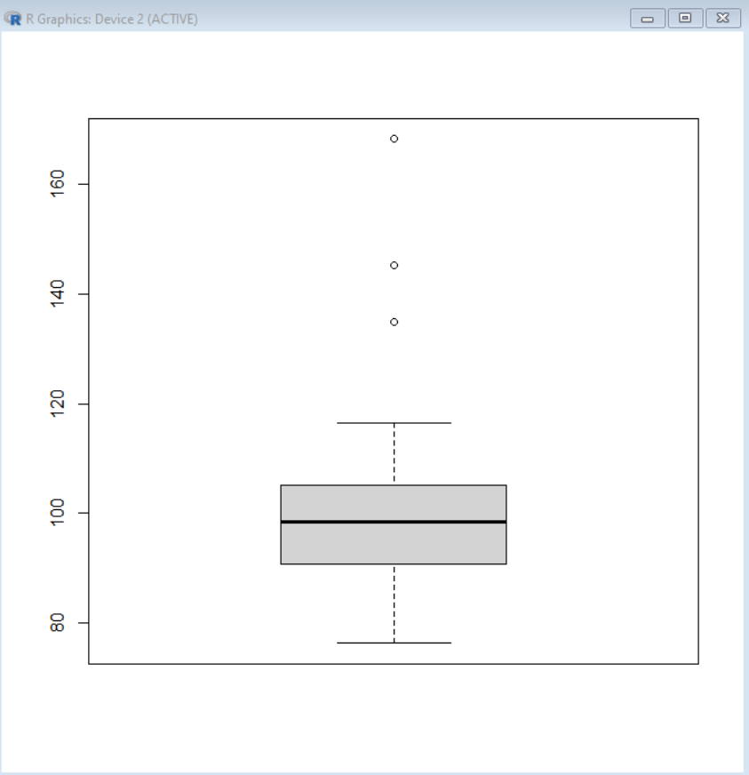

Step 3:After that find mean of respective data

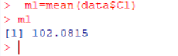

Step 4:Now calculate the standard deviation.

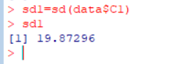

Step 5:Plot bell curve.

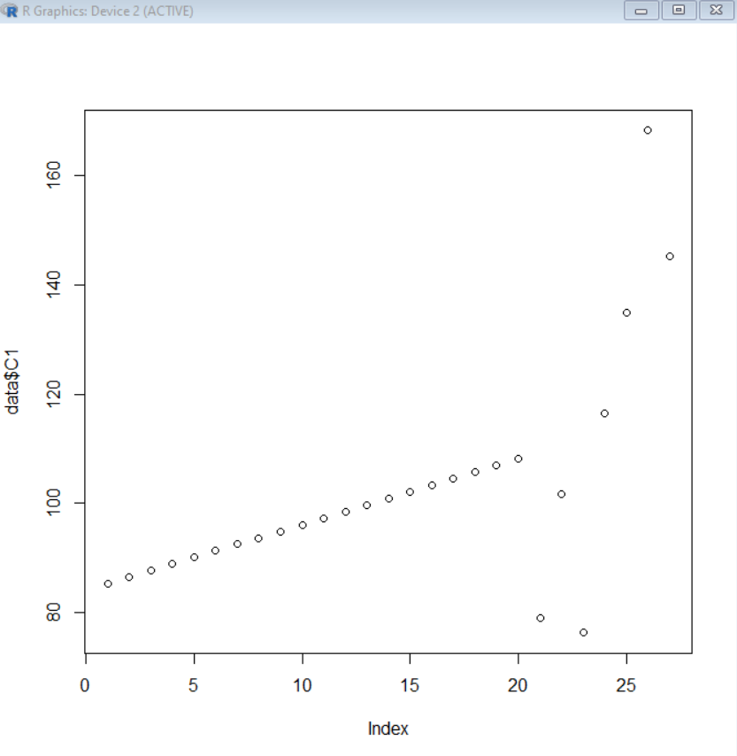

Step 6: At the end find T-Test value type following command.

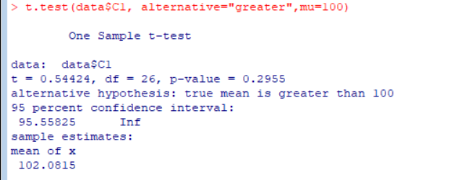

**CONCLUSION:**Thus we have implemented Hypothesis testing of a Single Population means successfully.